Lab Assignment 3
[Control Flow Structure]
Name: Atharvanath Jha
Roll no. 30 Section A

Question1: For any character entered through keyboard check whether the entered character is capital letter, small letter, a digit or special symbol.

#include <stdio.h>

int main()
{
char ch;

printf("Enter a character: ");
scanf("%c", &ch);

if(ch >= 'A' && ch <= 'Z')
{
printf("Capital letter\n");
}
else if(ch >= 'a' && ch <= 'z')
{
printf("Small letter\n");
}
else if(ch >= '0' && ch <= '9')
{
printf("Digit\n");
}
else
{
printf("Special symbol");
}

return 0;
}
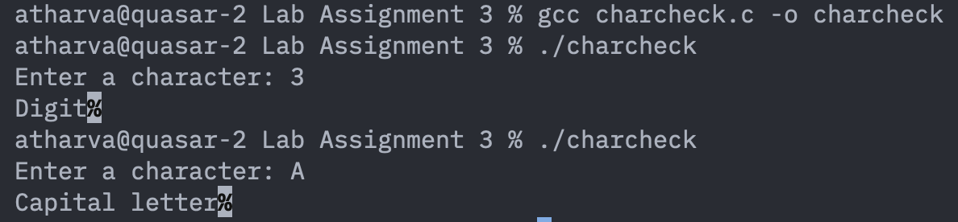
Question2: To find the greatest of 3 integers using two methods (a) if-else and (b) ternary operator.

2-a.
#include<stdio.h>
int main(){
int a, b, c;

printf("\nEnter the 3 numbers: ");
scanf("%d", &a);
scanf("%d", &b);
scanf("%d", &c);

if(a > b && a > c){
printf("\n%d is the greatest integer.", a);
}
else if(b > a && b > c){
printf("\n%d is the greatest integer.", b);
}
else{
printf("\n%d is the greatest integer.", c);
}

return 0;
}
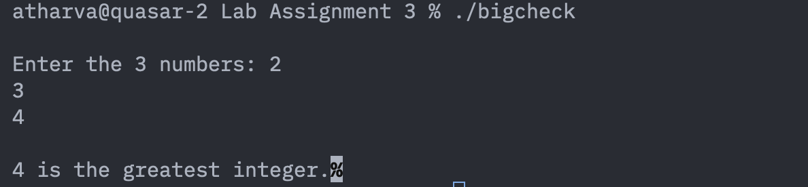

2-b:
//method 2
#include <stdio.h>

int main()
{
int a, b, c, largest;

printf("Enter three integers: ");
scanf("%d %d %d", &a, &b, &c);

largest = (a > b) ? ((a > c) ? a : c) : ((b > c) ? b : c);

printf("Largest int = %d\n", largest);

return 0;
}
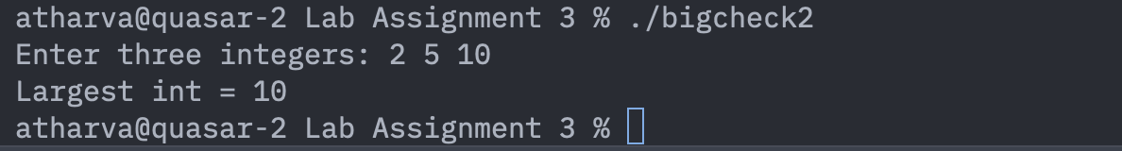

Question3: To implement calculator (+, -/, *, % ) using switch statements.
#include<stdio.h>
int main(){
float num1, num2;
float res;
char op;

printf("\nEnter two numbers: ");
scanf("%f", &num1);
scanf("%f", &num2);

printf("\nEnter the operator: ");
scanf(" %c", &op);

switch(op){
case '+':
res = num1 + num2;
printf("\n%f + %f = %f", num1, num2, res);
break;

case '-':
res = num1 - num2;
printf("\n%f - %f = %f", num1, num2, res);
break;

case '*':
res = num1 * num2;
printf("\n%f x %f = %f", num1, num2, res);
break;

case '/':
res = num1 / num2;
printf("\n%f / %f = %f", num1, num2, res);
break;

default:
printf("\nPlease enter valid input.\n");
break;
}
return 0;
}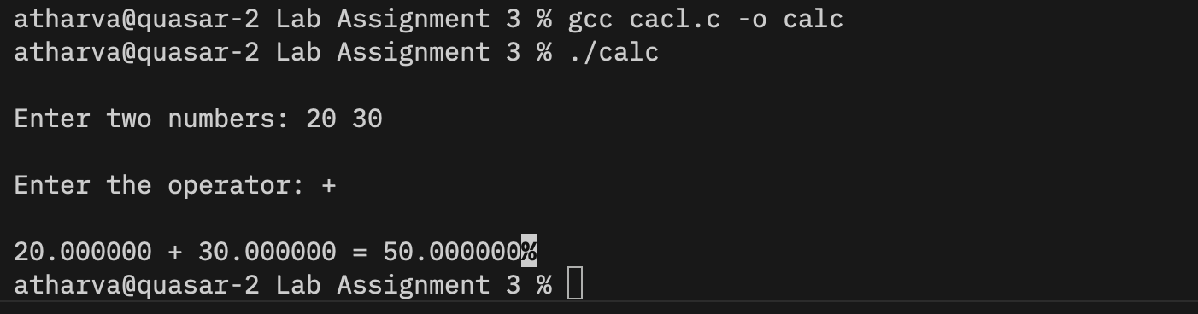
Question4: Display month name according to the month number using Switch Statement.
#include<stdio.h>
int main(){
int n;

printf("\nWhich month?");
scanf("%d", &n);

switch(n){
case 1:
printf("\nJanuary");
break;
case 2:
printf("\nFebruary");
break;
case 3:
printf("\nMarch");
break;
case 4:
printf("\nApril");
break;
case 5:
printf("\nMay");
break;
case 6:
printf("\nJune");
break;
case 7:
printf("\nJuly");
break;
case 8:
printf("\nAugust");
break;
case 9:
printf("\nSeptember");
break;
case 10:
printf("\nOctober");
break;
case 11:
printf("\nNovember");
break;
case 12:
printf("\nDecember");
break;
default:
printf("Invalid Input");
break;
}
return 0;
}
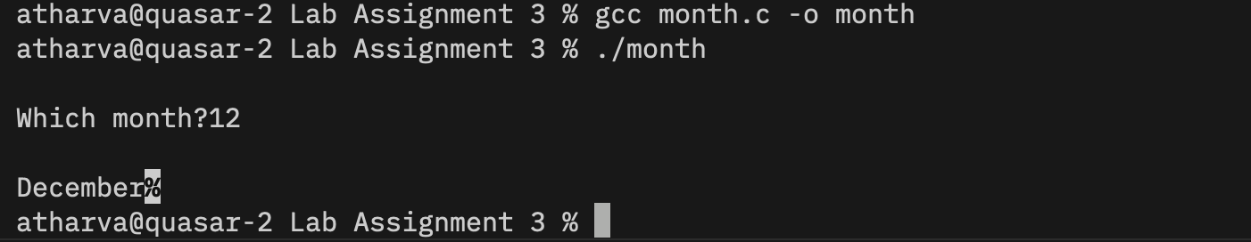

Question5: To check whether a number is: (a) even or odd (b) negative or positive by using if else.
#include <stdio.h>
int main(){
int num;

printf("Enter a number: \n");
scanf("%d", &num);

if(num < 0){
printf("%d is negative. \n", num);
}
else if(num > 0){
printf("%d is positive. \n", num);
}
else{
printf("%d is 0. \n", num);
}

if(num % 2 == 0){
printf("%d is even \n", num);
}
else if(num % 2 != 0){
printf("%d is odd \n", num);
}
else{
printf("invalid input");
}
}
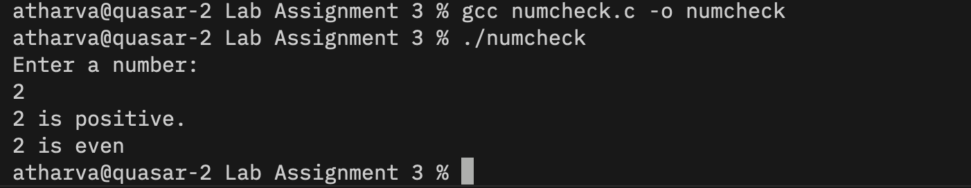

Question6: To check a no. say ‘n’ divisible by 5 and/or 8. Print the appropriate message accordingly.

#include<stdio.h>
int main(){
int num;

printf("enter number: \n");
scanf("%d", &num);

if(num % 5 == 0 && num % 8 == 0)
printf("\n%dis divisible by both 5 and 8. ", num);

else if(num % 5 == 0 && num % 8 != 0)
printf("\n%d is divisible by 5 but not 8.", num);

else if(num != 5 && num % 8 == 0)
printf("\n%d is divisible by 8 but not 5.", num);

else{
printf("\n%d is neither divisible by 5 nor by 8.", num);
}
}
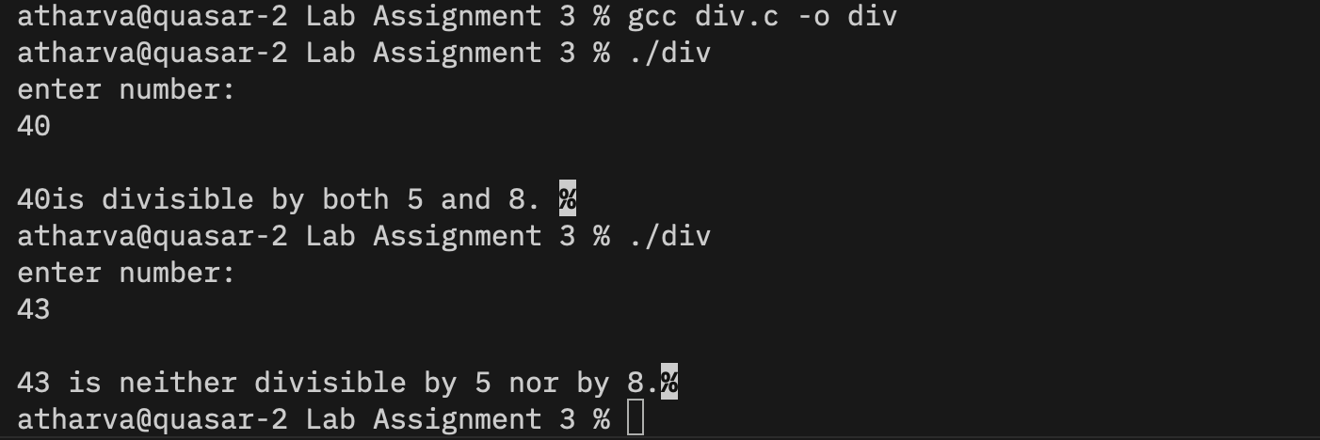

Question7: A library charges a fine for every book returned late. For the first 5 days the fine is 50 paisa, for 6-10 days fine is one rupee and above 10 days fine is 5 rupees. If you return the book after 30 days your membership will be canceled. WAP to accept no. of days the member is late to return the book and display the fine or appropriate message.

#include<stdio.h>
int main(){
int days;
float fine;

printf("\nHow many days have you delayed?");
scanf("%d", &days);

if(days < 5){
printf("\nYour total fine is: ");
fine = 0.5 * days;
printf(" %f", fine);
}
else if(days > 5 && days < 10){
printf("\nYour total fine is: ");
fine = 1 * days;
printf(" %f", fine);
}
else if(days > 10){
printf("\nYour total fine is: ");
fine = 5 * days;
printf(" %f", fine);
}
else{
printf("Invalid input");
}

}

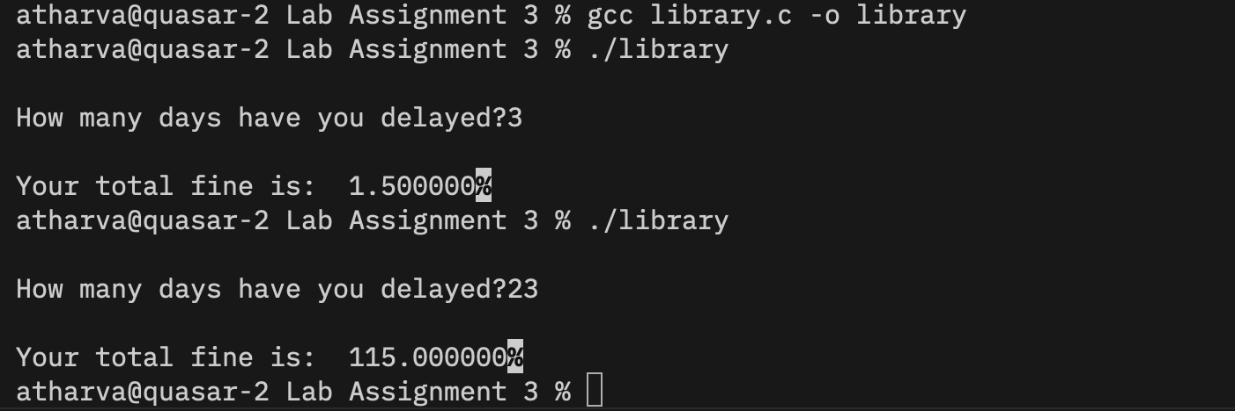
Question8:
Write a program to read in 5 numbers and compute the average, max, min,
standard deviation.

#include<stdio.h>
#include<math.h>
int main(){
float a, b, c, d, e;

printf("\nEnter the 5 values spearated by space.");
scanf("%f", &a);
scanf("%f", &b);
scanf("%f", &c);
scanf("%f", &d);
scanf("%f", &e);

float mean, min, max, std_dev;

mean = (a + b + c + d +e)/5;

printf("\nMean = %f", mean);

min = a;
max = a;

if(b < min)
min = b;

if(c < min)
min = c;

if(d < min)
min = d;

if(e < min)
min = e;

if(b > max)
max = b;

if(c > max)
max = c;

if(d > max)
max = d;

if(e > max)
max = e;

printf("Minimum = %f\n", min);
printf("Maximum = %f\n", max);

std_dev = sqrt(
((a - mean) * (a - mean) +
(b - mean) * (b - mean) +
(c - mean) * (c - mean) +
(d - mean) * (d - mean) +
(e - mean) * (e - mean)) / 5
);

printf("standard deviation = %f", std_dev);

}
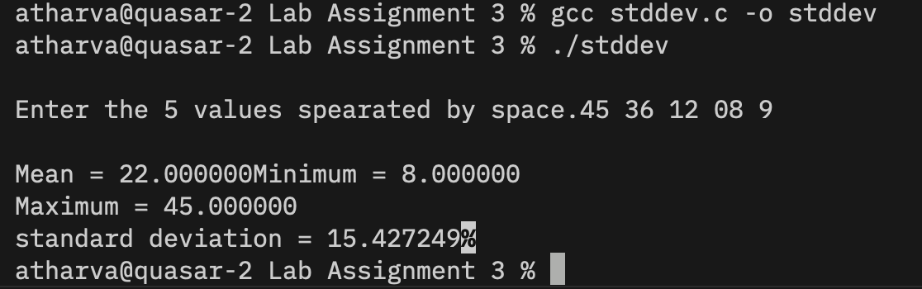

Question9:
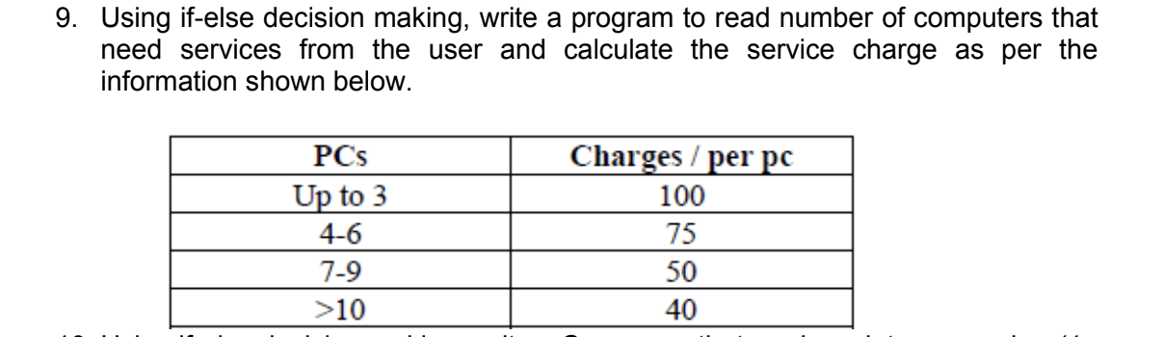
#include<stdio.h>
int main(){
int num;

printf("\nHow many computers need servicing?");
scanf("%d", &num);

if( num <= 3)
printf("\nTotal cost = ₹%d", num*100);
else if( num > 3 && num < 7)
printf("\nTotal cost = ₹%d", num*75 );
else if( num > 7 && num < 10)
printf("\nTotal cost = ₹%d", num*50);
else if( num > 10)
printf("\nTotal cost = ₹%d", num*40);
else
printf("\nInvalid Input");

}

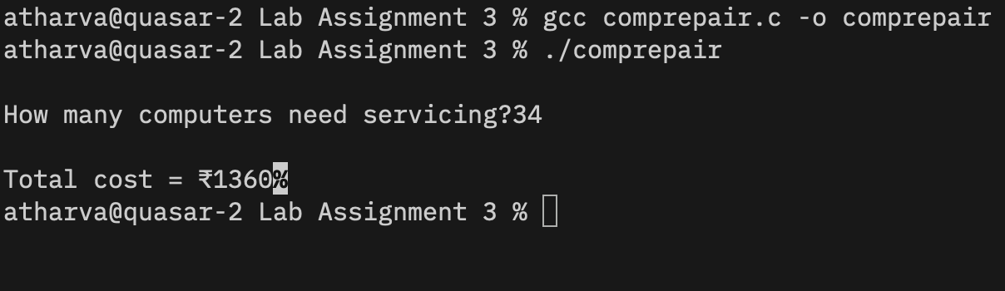

Question10: Using if-else decision making, write a C program that reads an integer number (1–12) representing a month of the year and displays the total number of days in that month. If the user enters a number outside the range of 1 to 12, display an appropriate error message.

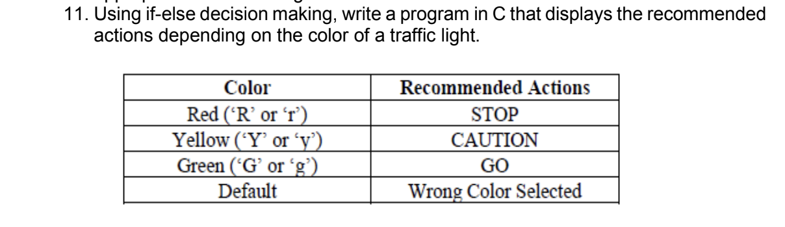
#include <stdio.h>

int main() {
char color;

printf("Enter a color: ");
scanf("%c", &color);

if (color == 'R' || color == 'r'){
printf("\nSTOP");
} else if (color == 'Y' || color == 'y'){
printf("\nCAUTION");
} else if (color == 'G' || color == 'g'){
printf("\nGO");
} else {
printf("\nINVALID COLOR");
}

}

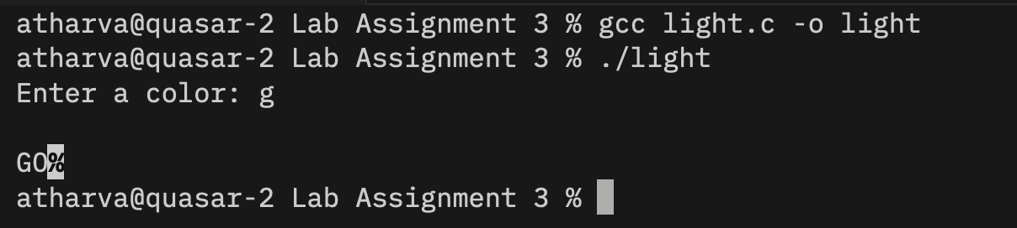

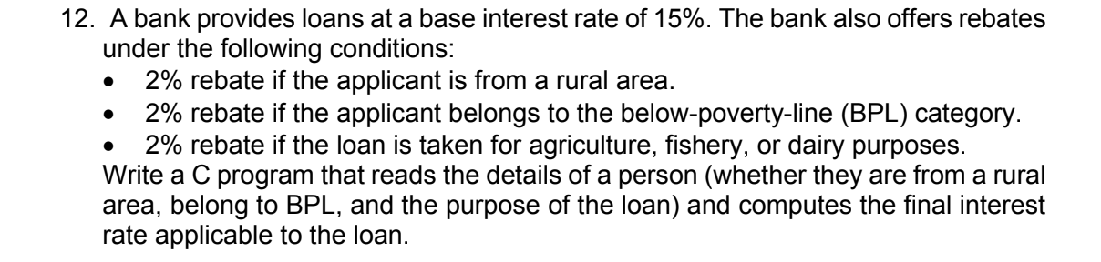
#include<stdio.h>
int main(){
float amt, fin_amt;
char ans1, ans2, ans3;

printf("\n How much do you want to borrow? ");
scanf("%f", &amt);

printf("\n Your total payble amount with interest of 15%% will be: ");
fin_amt = amt + 0.15*amt;
printf("\n Final amt without rebates: ₹%f", fin_amt);

printf("\n Answer the following in y or n to get rebates!");

printf("\n Are you from a rural area?");
scanf(" %c", &ans1);

if (ans1 == 'y' || ans1 == 'Y'){
fin_amt = fin_amt - (0.02*amt);
}
else{
printf("\n You're not eligible for this rebate!");
}

printf("\n Do you categorise Below Poverty Line?");
scanf(" %c", &ans2);

if (ans2 == 'y' || ans2 == 'Y'){
fin_amt = fin_amt - (0.02*amt);
}
else{
printf("\n You're not eligible for this rebate!");
}

printf("\n Are you taking loan for Agricutlure, Fisheries, or Dairy?");
scanf(" %c", &ans3);
if (ans3 == 'y' || ans3 == 'Y'){
fin_amt = fin_amt - (0.02*amt);
}
else{
printf("\n You're not eligible for this rebate!");
}

printf("\n Your total payable amount is: ₹%f", fin_amt);

}
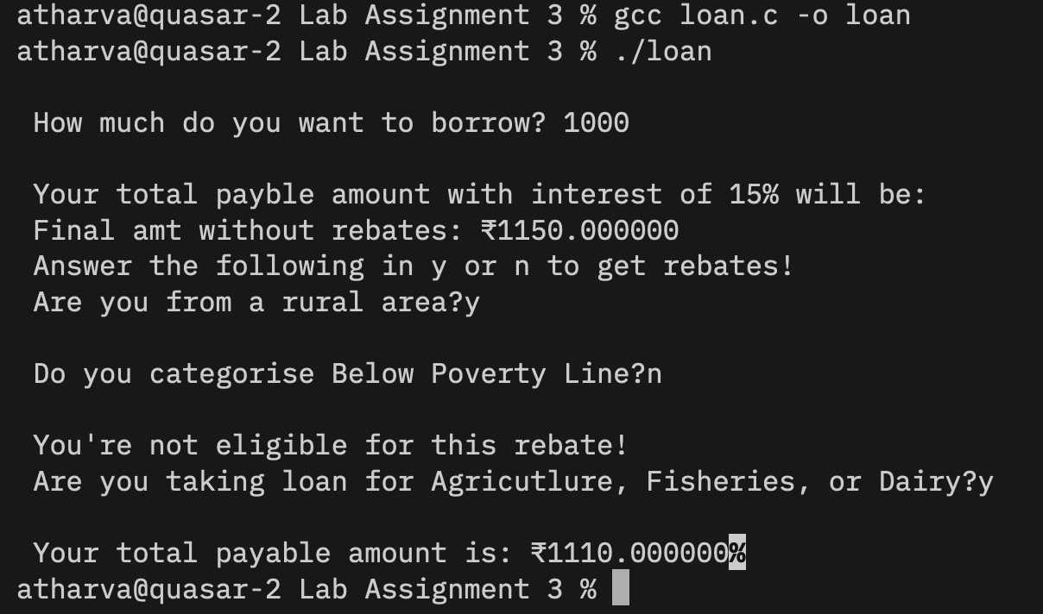

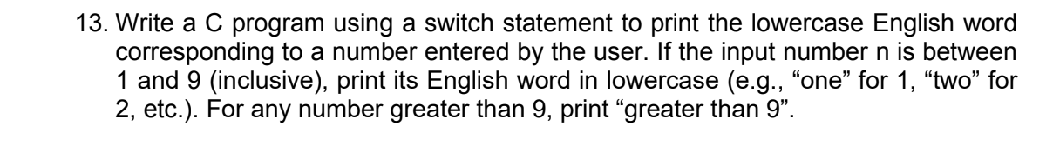
#include<stdio.h>
int main(){
int num;

printf("\n Number between 1 to 9: ");
scanf("%d", &num);

switch(num){
case 1:
printf("\n ONE");
break;

case 2:
printf("\n TWO");
break;

case 3:
printf("\n THREE");
break;

case 4:
printf("\n FOUR");
break;

case 5:
printf("\n FIVE");
break;

case 6:
printf("\n SIX");
break;

case 7:
printf("\n SEVEN");
break;

case 8:
printf("\n EIGHT");
break;

case 9:
printf("\n NINE");
break;

default:
printf("\n INVALID INPUT");
break;
}
}
